-🡪you can create a line chart for example for your ec2 instance..

Clodwatch dashboard-🡪 Add widget-🡪Line chart-🡪 Ec2 instance🡪 Per-instance metrics🡪Select metrics

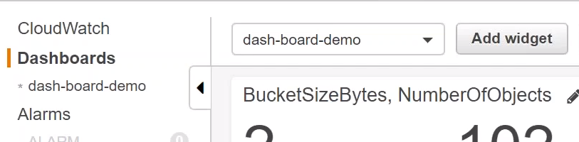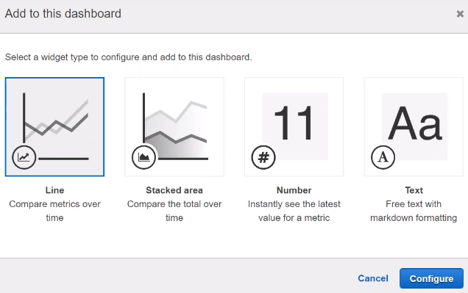

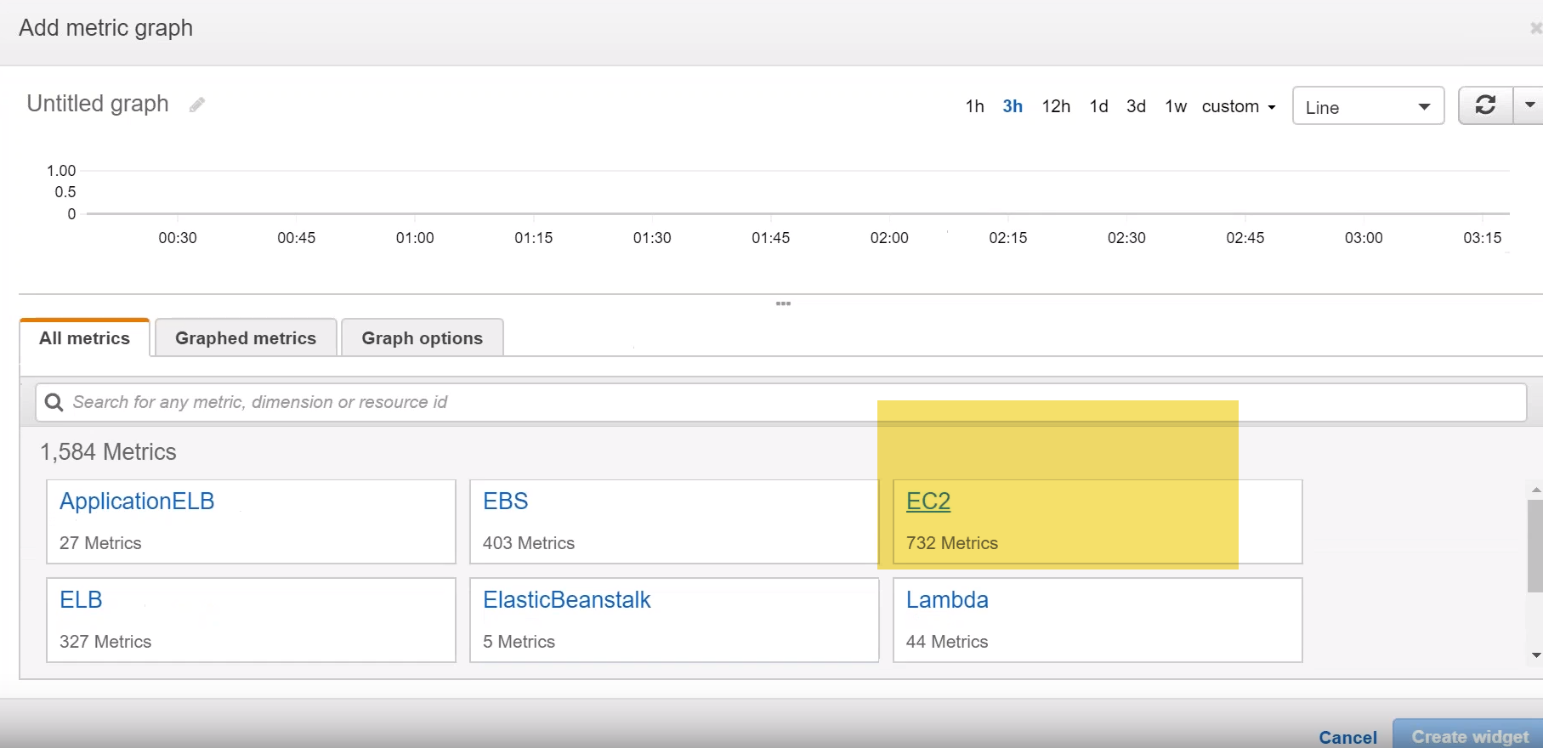

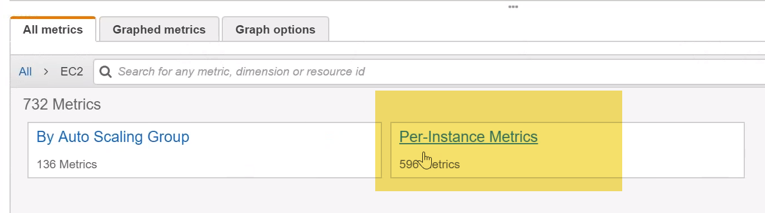

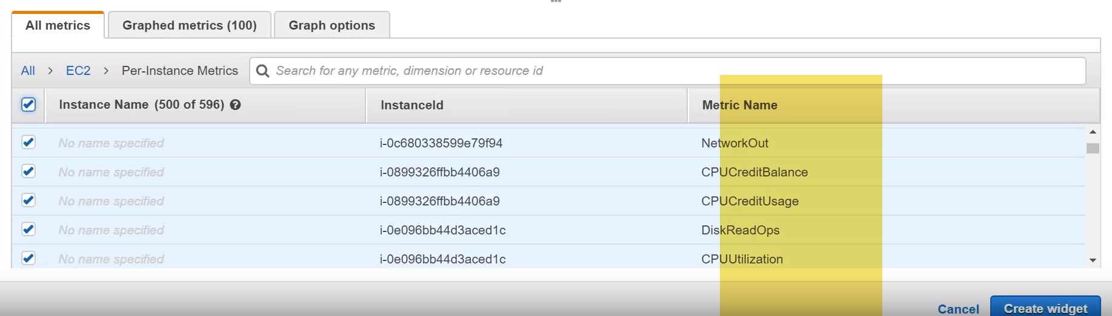

Metrics not showing anything(EC2 stopped state in demo)-🡪it needs a running instance and some data to be picked up. It is seen last one week what happens if I can trigger some charts okay… we have some amount of data to show some charts there .

-🡪you have to create your dashboard according to your customers needs. So if your customer wants to know how much you CPU credit…

UseCase: amount of data that you are having in your EBS..,how many snapshots you have… how much storage you have… when the snapshots.

you can use a combination of those things and then you can have a dashboard and give it to your monitoring team or you can configure an alarm based on that so you can have a alarms tied it to your dashboard

**-🡪If anybody wants to know what is happening in your account …they come to this dashboard and quickly see things …I want to modify or these are things that are causing more budget or billing… then I can go and monitor it or edit it or delete it.**

UseCase Ex:I want to show number odf objects in S3

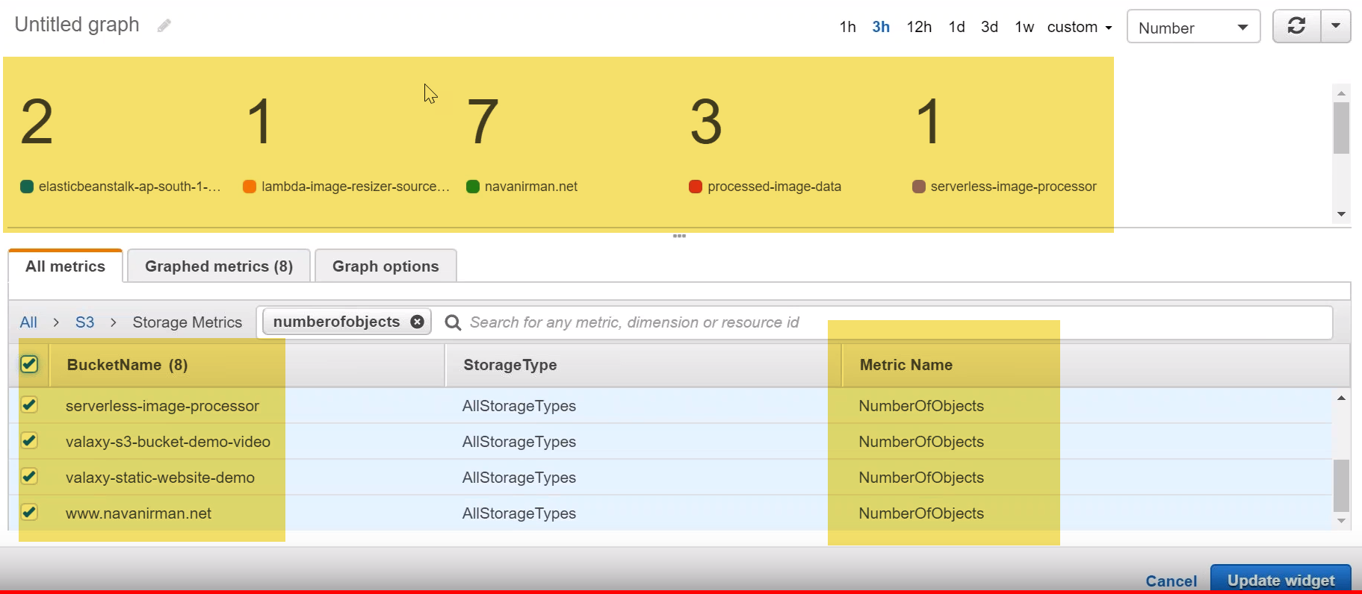

UseCase We also have size of bucket also…

------------------------------------------------------------------------------------------------------------------------------------------------------------------------------------------------------------------------------------------------------------------------------------

how you can create your own custom dashboard like the one that you are seeing now.. 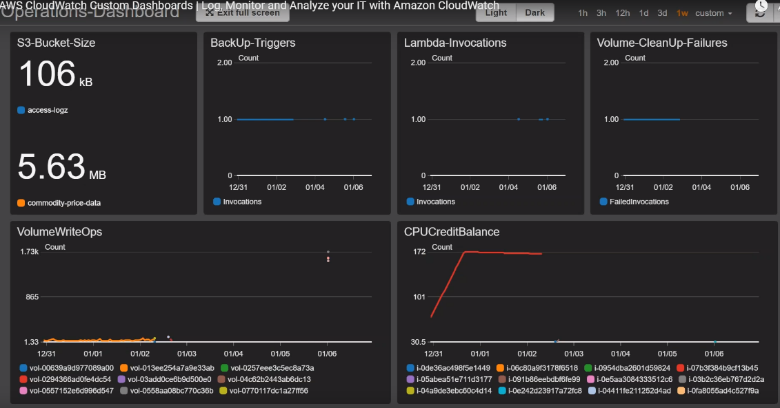

Here I have created at six different dashboards.

1. one is for an s3 bucket size which lists out the size of the objects that are in my bucket.
2. Then I have a backup triggers …where the today's back up are being happened or not
3. I also have a lambda invocation, which gives me aware of how many lambdas I have triggered on a particular week or a month and
4. then I also have another volume count which tells me whether the volume cleanup failures are happening or not.

say for example: I have an automated cleanup process and I want to be notified whenever there is an failure of volume to be cleaned up then I will get a notification here.

1. then I also have a EBS volume write-offs that is number of write operations that is happening in my EBS volume and

Ex: if there is a Sudden spike, I want to investigate then is: I have to do is come here and then select a time frame which is of my interest and then look at which volume is having high i/o and then if I go to the volume itself(EBS)I can have more information about the volume.

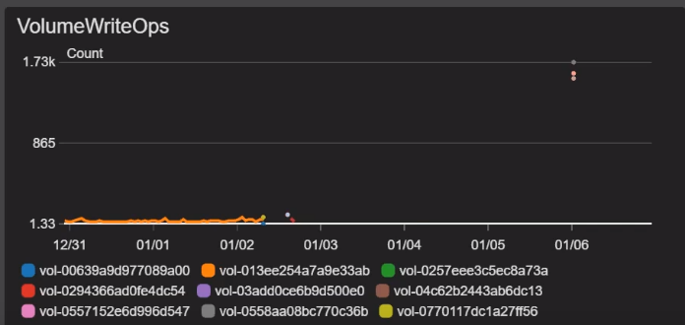

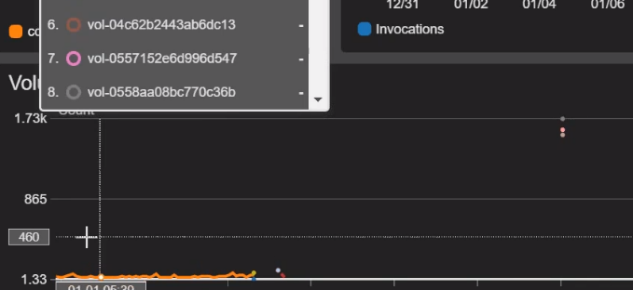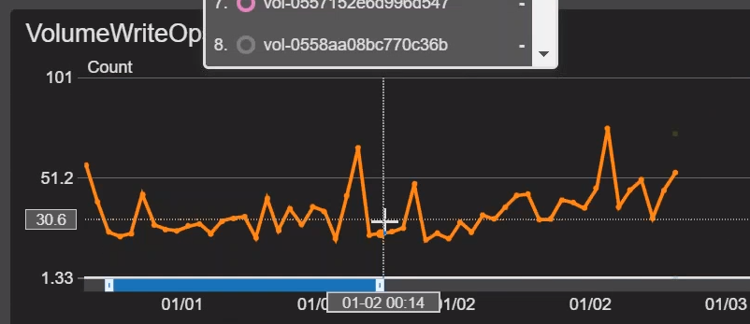

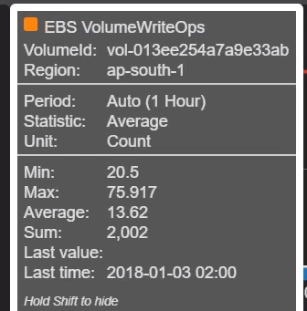

6.)I have a CPU burst credit balance metric that is shown up here…

And then if I want to investigate which instance is having more CPU consumption at any point in time.

1.)Lets create a New dashboard…Under actions…

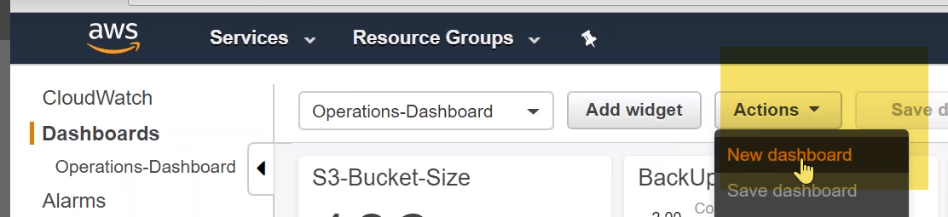

Give dashboard name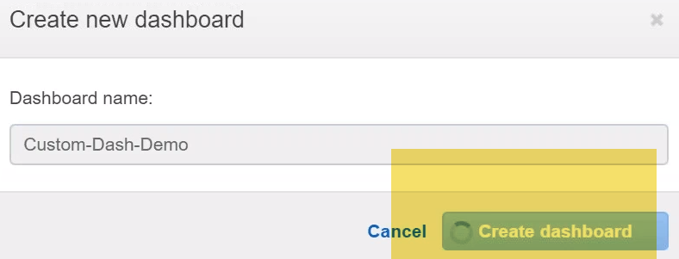

1. Add widget-🡪 Line-🡪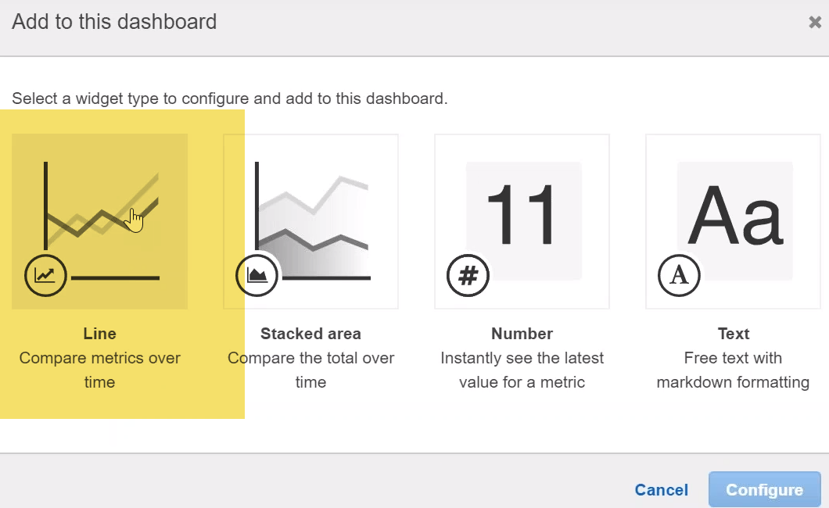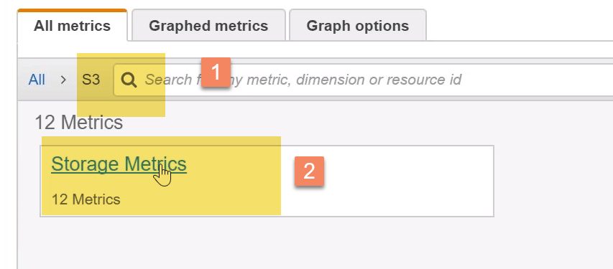

choose s3 -🡪click on storage metrics-🡪 and I'm going to be interested on the Bucket sizes-🡪 so I'm just going to filter by that-🡪

1. Choose bucket name
2. Choose metric
3. Choose number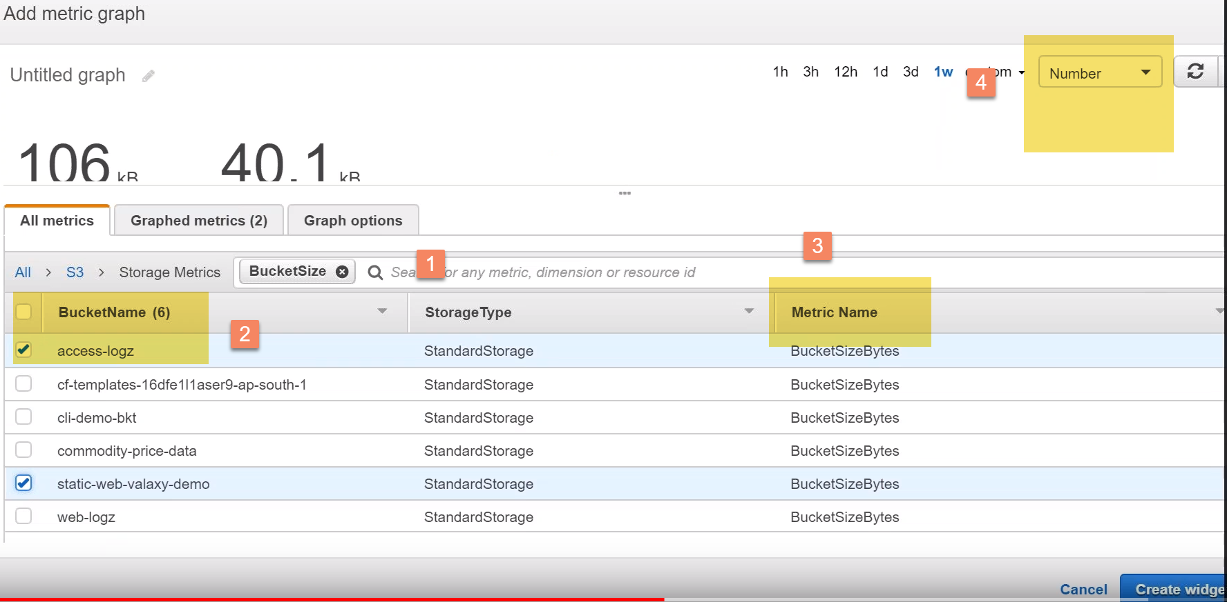

click on create widget…

Each of those widgets you will have an option to resize it and there are some default sizes and you can also set it to auto refresh or you want it for a different time frame and how you want to setup the widget itself ….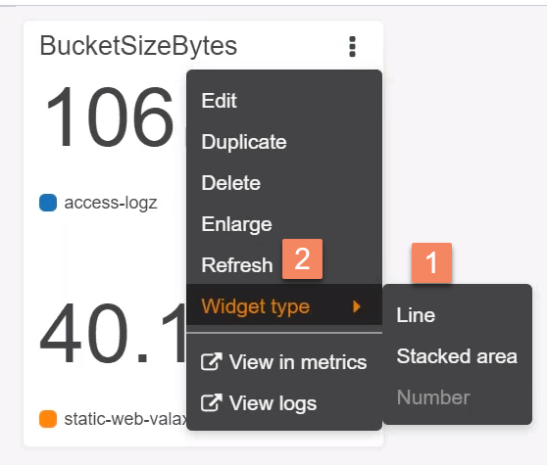

2.)one more…call it as a line chart

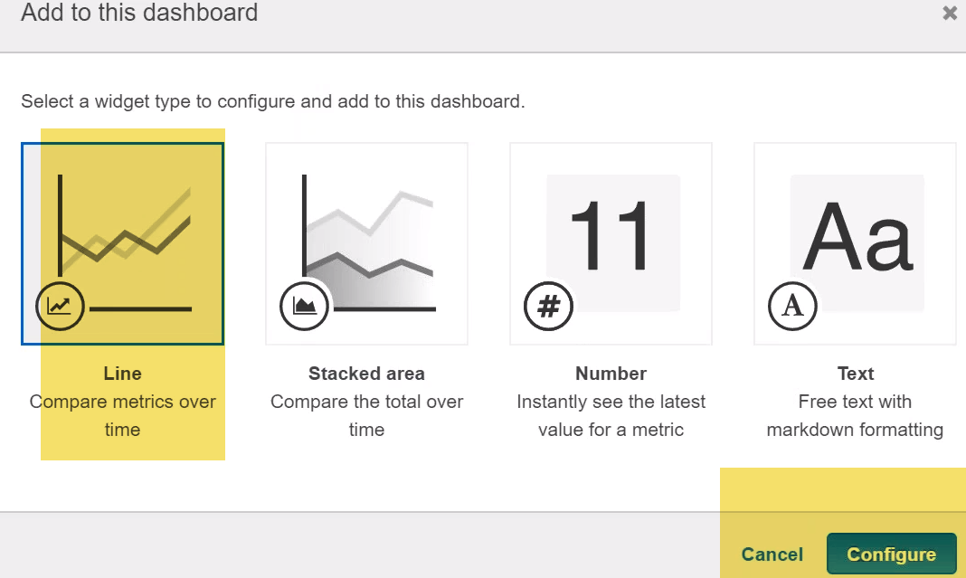

b.)I'm going to create one for lambda 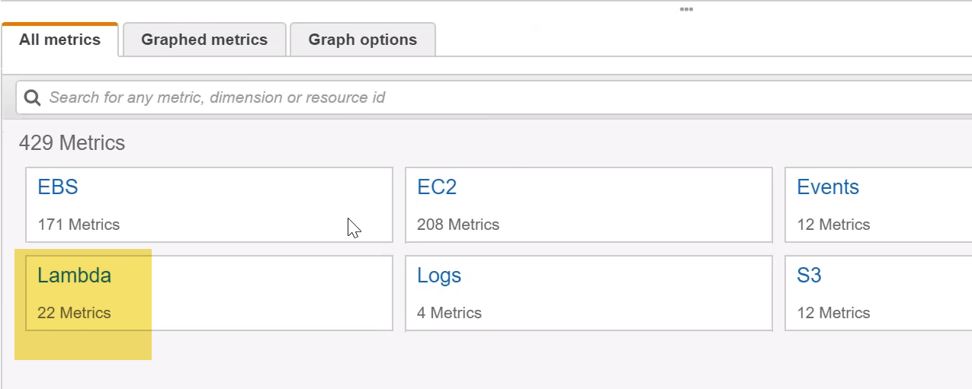\ I wanted to do it for all invocations . 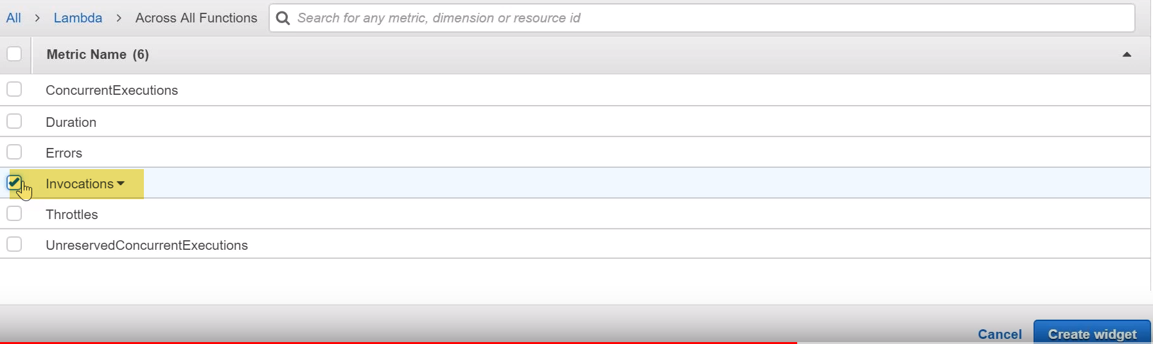

click on create widget.

3.)For ec2-🡪line🡪Ec2-🡪Per instance metrics-🡪 CPUCreditBalance-🡪select all instances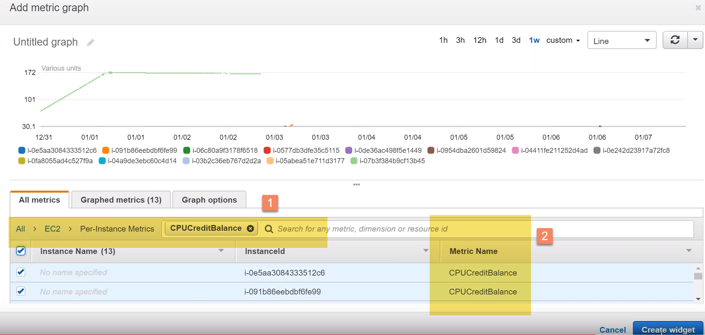

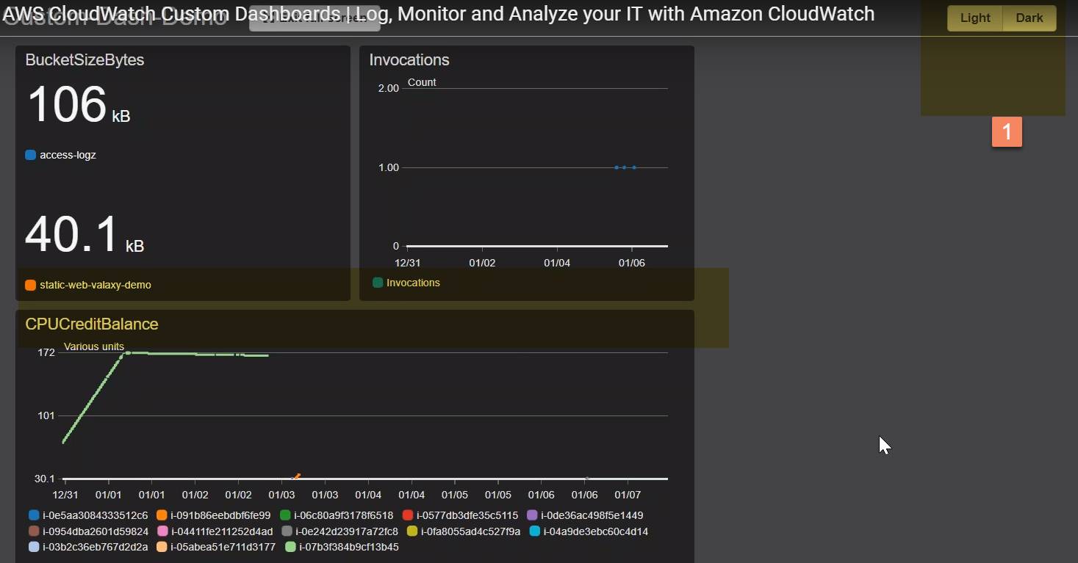

CPU print balance chart -🡪drag it down …so that I should be able to resize it to the size I want… let's say I want to make it into two sizes now…

I’m able to able to focus on how on **which ec2 instance is having more CPU and I can easily identify the one that is underperforming and look at improving the performance**

It also helps your L1 team to focus on items which needs highest importance rather than looking at the whole alerts or events that is happening in your account…

------------------------------------------------------------------------------------------------------------------------------------------------------------------------------------------------------------------------------------------------------------------------------------

AWS CloudWatch Events | Set Rules | Monitor EC2 Instance State | Test

how you can use Cloud watch events ..so that you can monitor any changes in your system state.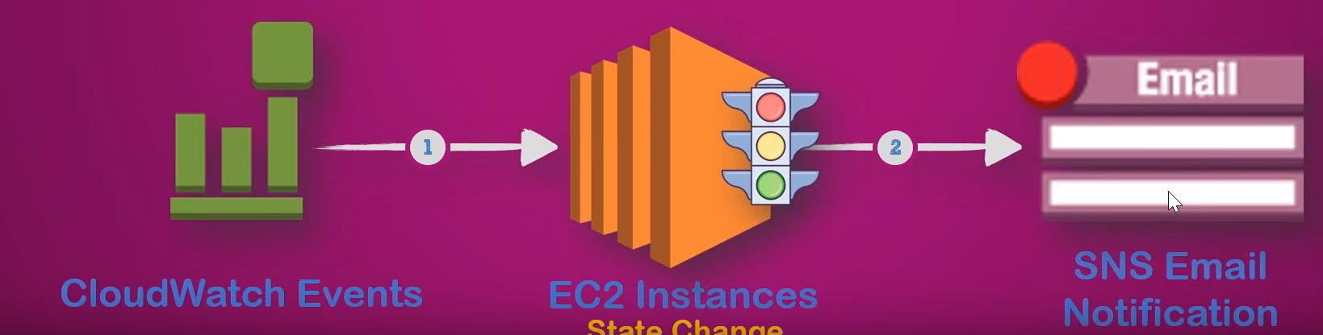

Cloud watch events delivers you a near real-time stream of system events… say you have an ec2 instance and it is for some reason gone for a reboot and you want to know to get notified with a change of state from running to rebooting and then coming back to available or running state.

You might use this change of stage to trigger some backup actions say take a snapshot of all the EBS volumes attached to the EC2 instance or maybe attach it to another instance because this server is having some issues and it is rebooting …

You can you can use this Change state for a variety of purposes…

-🡪In this case what I'm going to do is I’m going to send an SMS email notification when our state of my server changes.

1. Keep Ec2 instance running.
2. Cloudwatch-🡪create an event here.
3. The first step in building in the event is creating a rule or in other words when I want to event my to happen and what is the service that I am going to monitor. 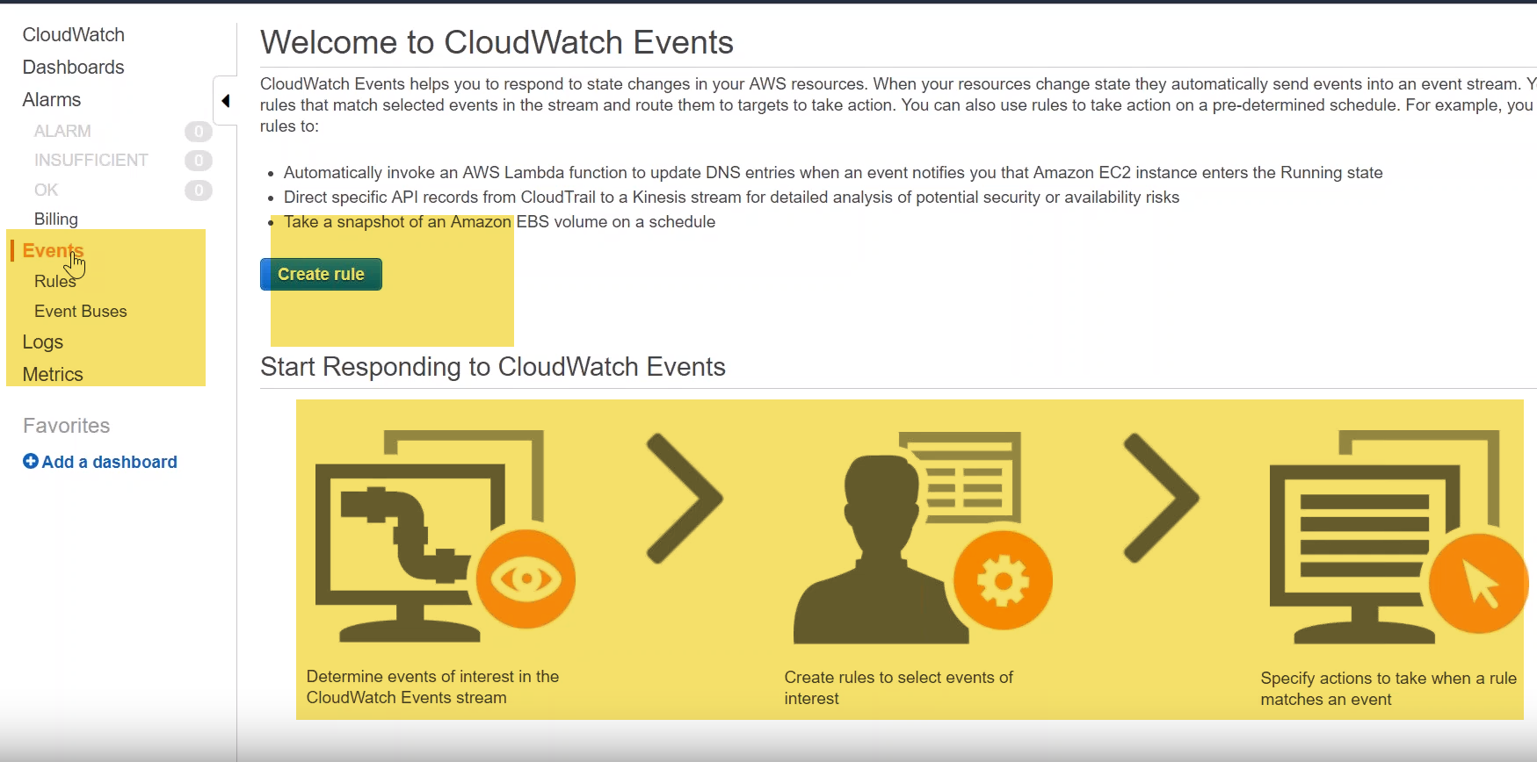

my event pattern it is based on the service…ie.., EC2 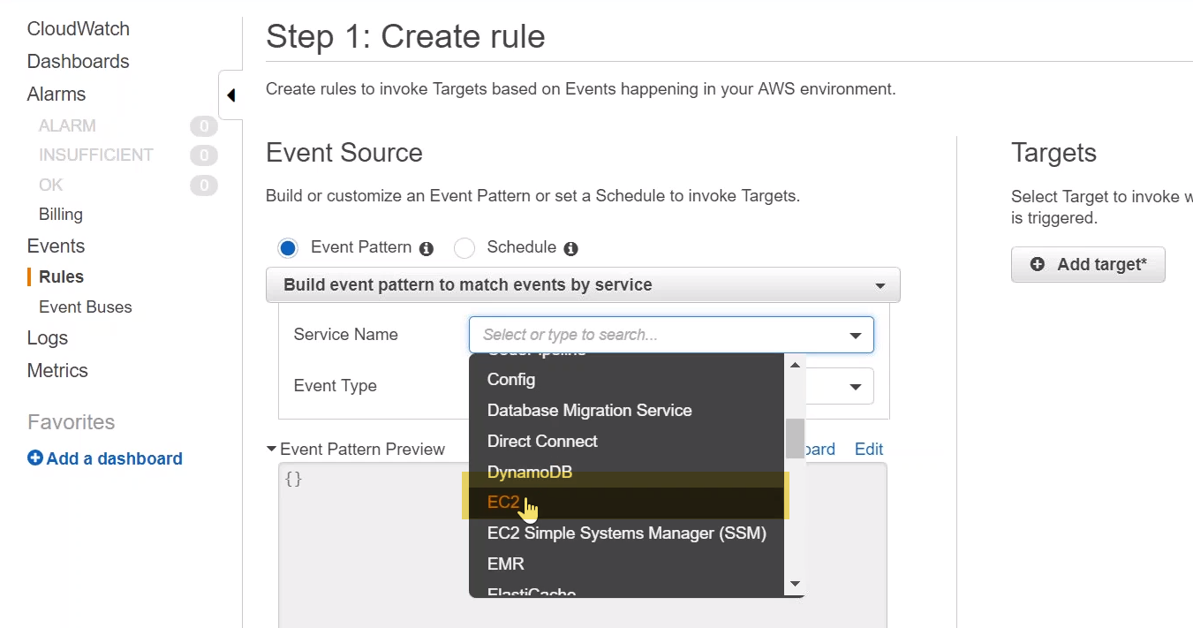 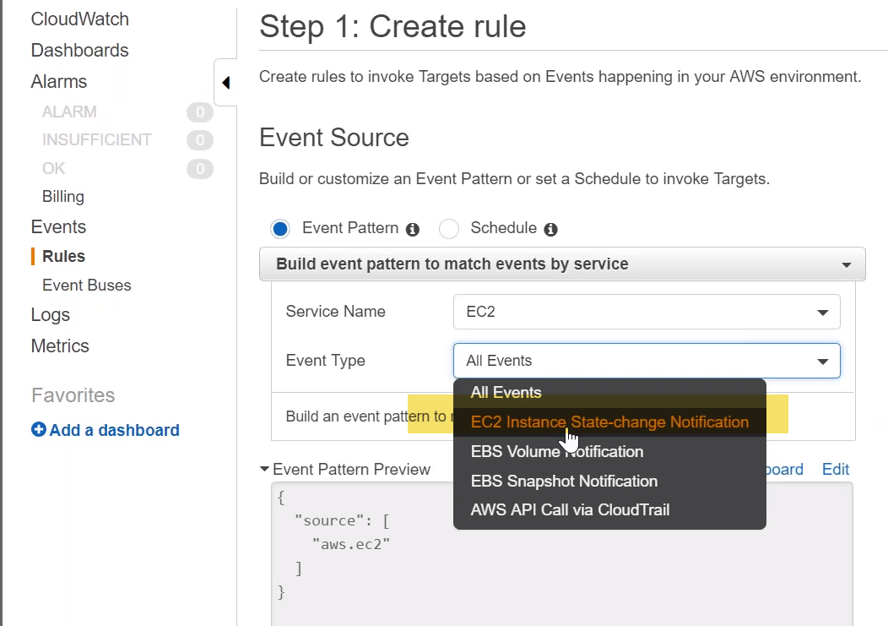

Event type: choose instance state notification…. and if you want to get notified only for particular states say running or if it is going to be happening only when it's shutting down or stopped or terminated or all of them that is also possible.

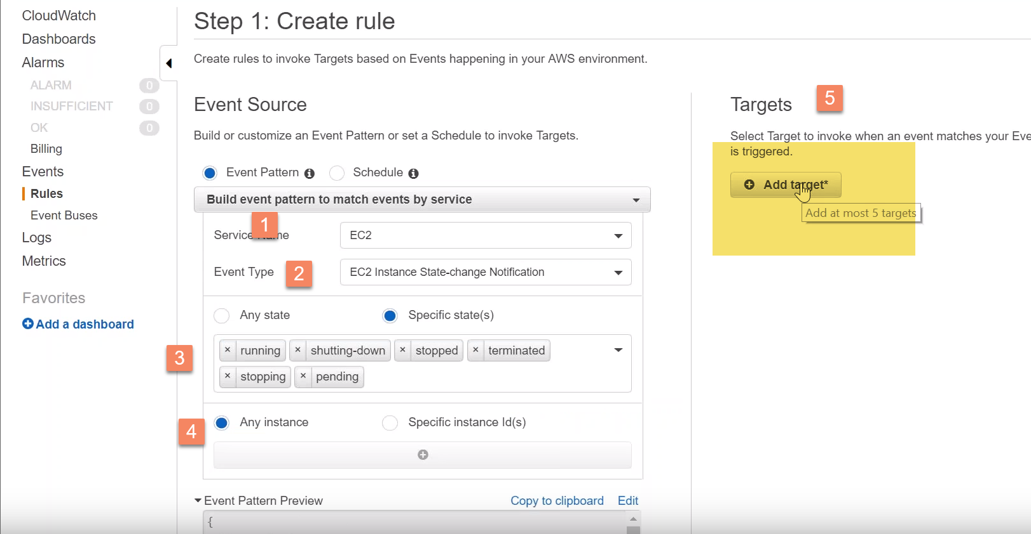

Do you are interested in and do you want to do that only for a particular instance or all the instances???

Click on target and I'm going to choose an SNS topic …so my L1 support team will get an email address whenever there is a state change for our server .

let us go ahead and create our event….

2.)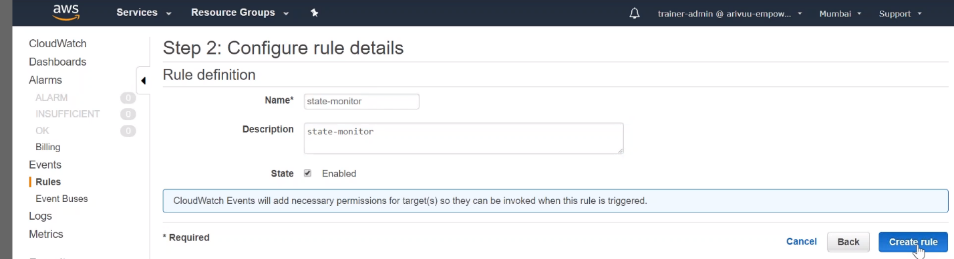

3.)still no alarm… 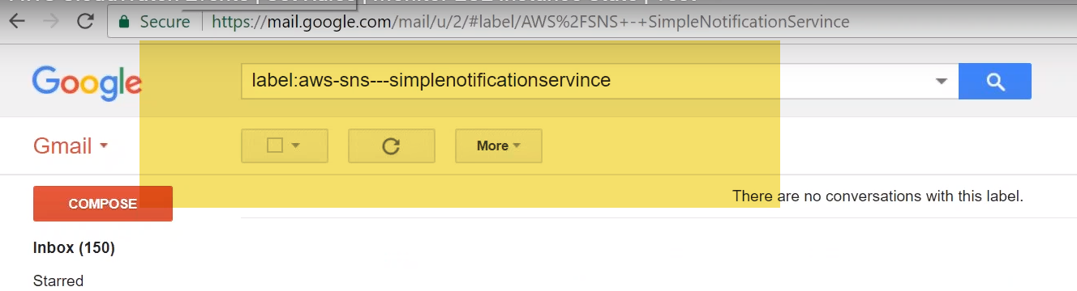

4.) let us go ahead and change the state of our server--🡪Stopped

very soon I should be getting an email from Amazon…

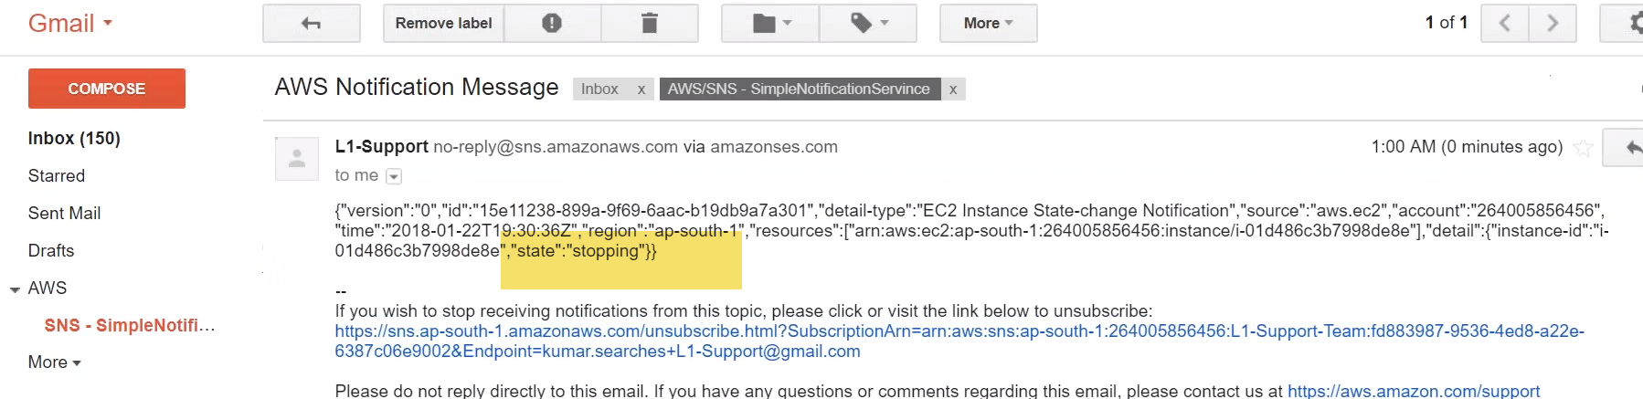

AS soon as server is stopped I should be getting one more email which says my state is in stopped state now. 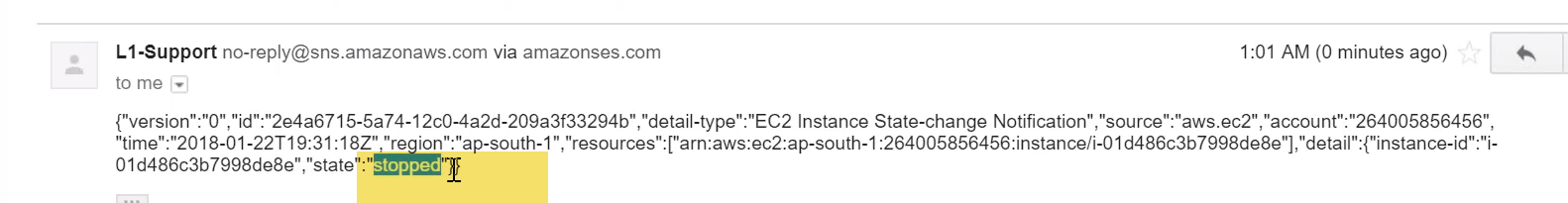

**Terminate:**

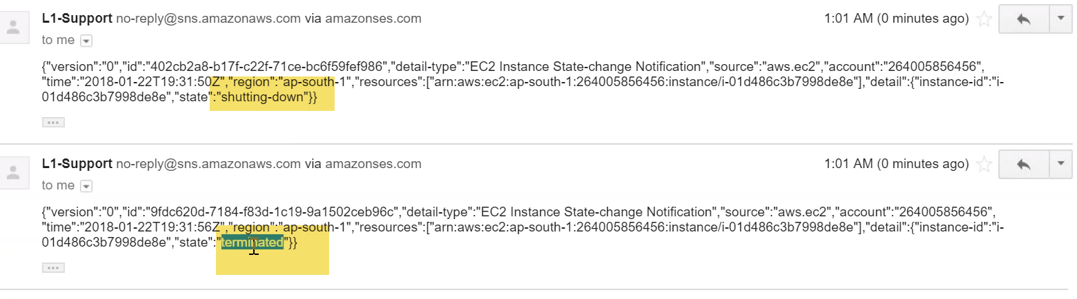

That is how you set up events in your cloud watch and then monitor whenever state of a server changes and you can trigger some actions based on that… In this case that you action was a simple SNS notification to my support team saying that a certain state of the server has changed.

**So you can go ahead and set up complex activities say recovery of a server or might be a backup or might be a restoration of some other activities…**

# AWS CloudWatch Metric Alerts | Set Alarms | Monitor EC2 CPU Utilization | Test

how you can use cloud watch alarms…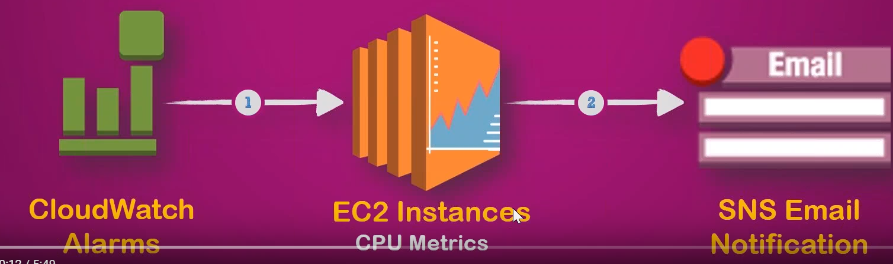

alarm is basically a trigger for one or more actions based on the metric that you want to monitor.

**example** let us say you want to monitor an ec2 instance and the metric that you are interested is CPU utilization.

So lets go ahead and create an alarm and say whenever CPU utilization is above a certain threshold say for example 55 percentage or 60 or 90 whichever you want to get an email or an SNS notification..

1. ec2 instance running.

go to my monitoring section and you find that CPU utilization is almost nil or there is not much utilization currently happening.

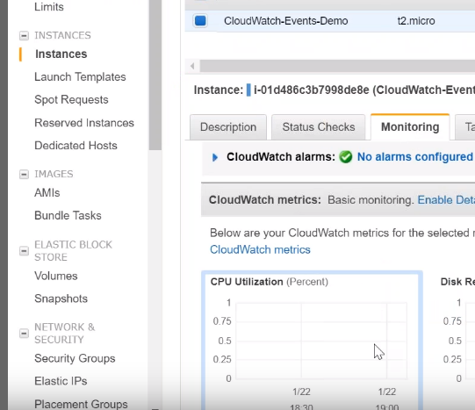

And there are no alarms configured as you can see here it is highlighted here …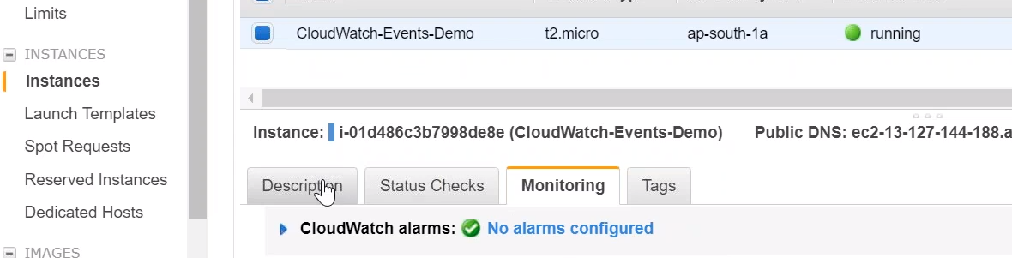

2.) what I'm going to do is I'm going to copy this instance ID…. which might be needed to create my alarm. 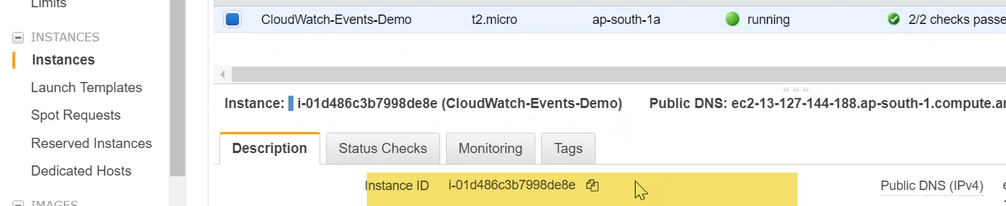

2.)In cloud watch dashboard …go ahead and create an alarm. 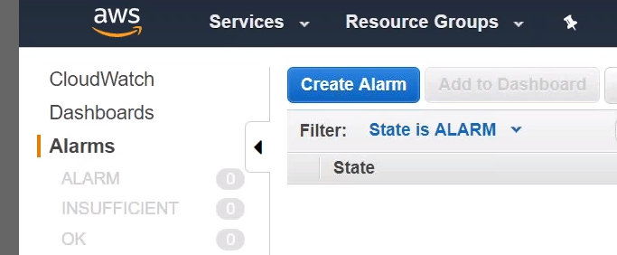

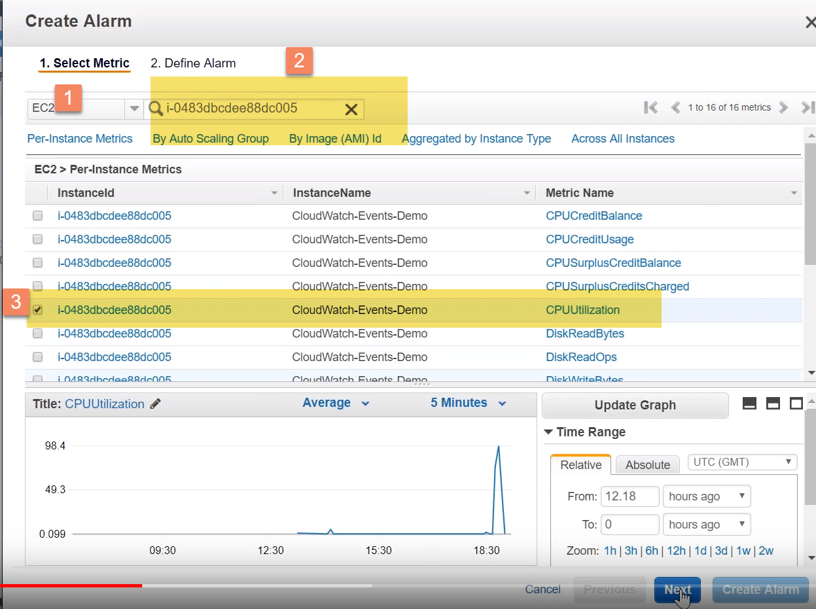

ec2 metric -🡪 filter by the instance ID -🡪 search for that instance and search for CPU utilization 🡪click on next.

3.)Alaram name: CPU monitor.

Period: if you want to monitor or if you want your alarm to be very sensitive go ahead and choose a one-minute monitor

statistic : average CPU utilization

when do I want to trigger my alarm??? CPU utilization >51%.

… I want an alarm to be sent to me

how often do I want to measure it ???(Datapoints) : so I'm going to say 5 data points and

Out of 5 data points even if 3 of them are more than fifty one percentage …I want to send and trigger or alarm to my email address…

For doing that… you can scroll down **under actions** 🡪Send notification to …. I have set up an SNS topic L1 support team ( they'll be getting an email whenever then alarm is triggered).

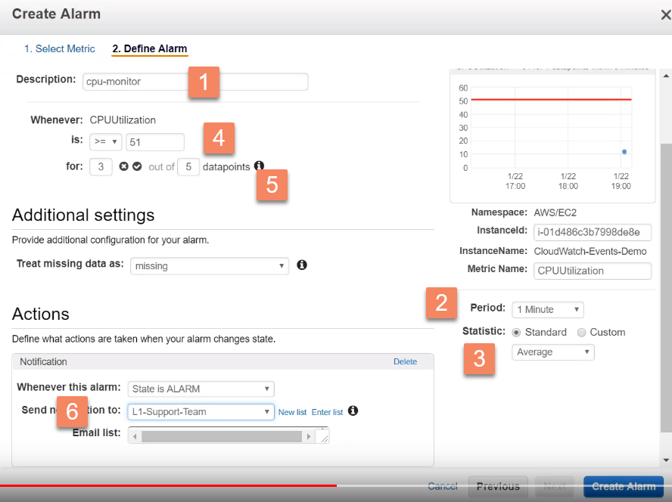

4.)Do some activity in my ec2 instance which will increase my CPU utilization…

I'm going to stress my CPU so that it will spike up above 50% . 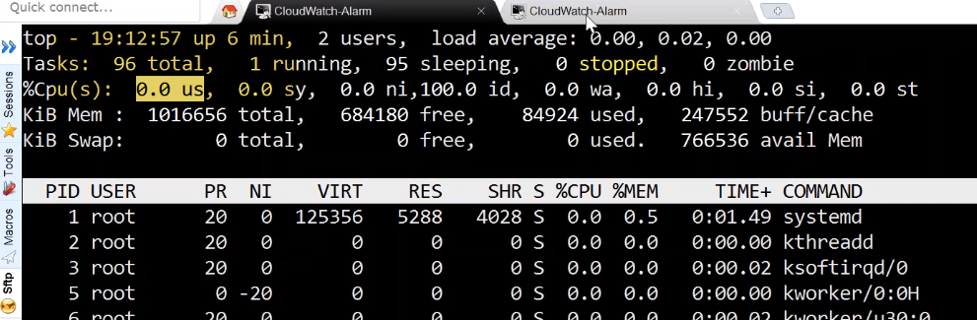

average CPU is 0%...

Use stress which is going to really spike up my CPU…

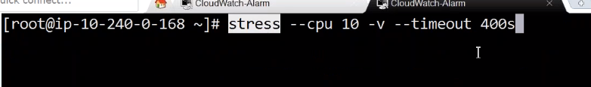

It is slowly increasing from 0% percentage it has gone all the way to 100%.

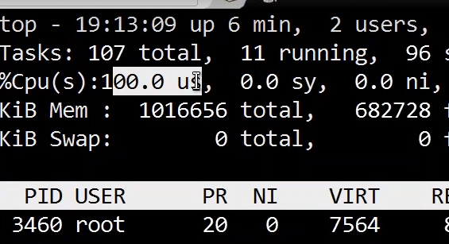 and it is going to stay close to about 5 minutes… So this should be enough to trigger our alarms.

5.) 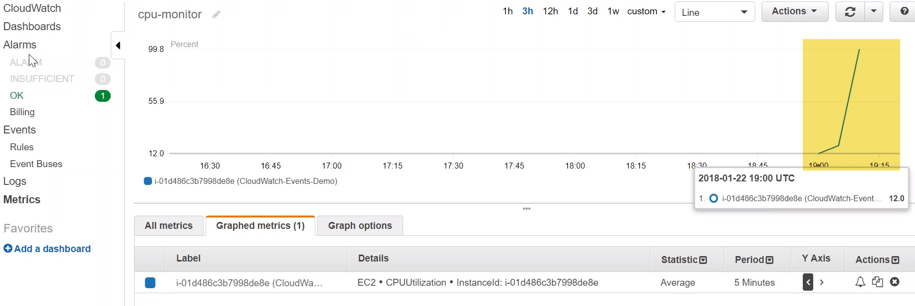

It is already above my red line and I'm just waiting for a couple of more data points.

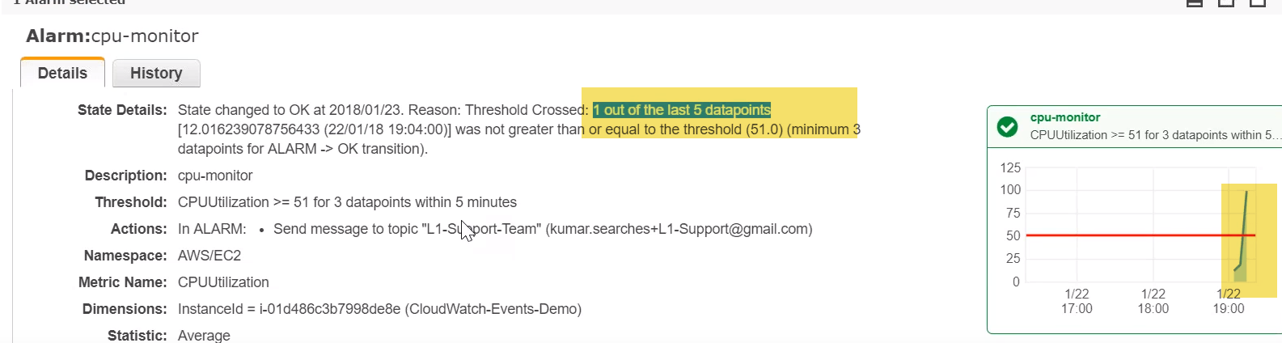

One data point is already high and more than 51% CPU utilization …So just two more minutes and we should be able to see an alarm triggered in our dashboard.

1. Goto Alarm history:

You have an alarm triggered… if I go to my alarm history I should be able to find that two of the next two data points also trigger two alarm. 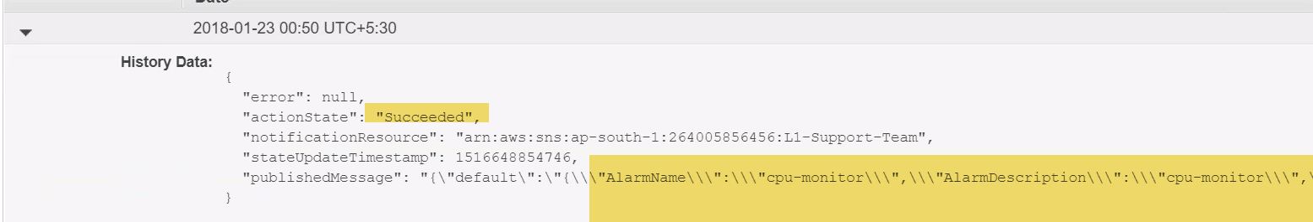

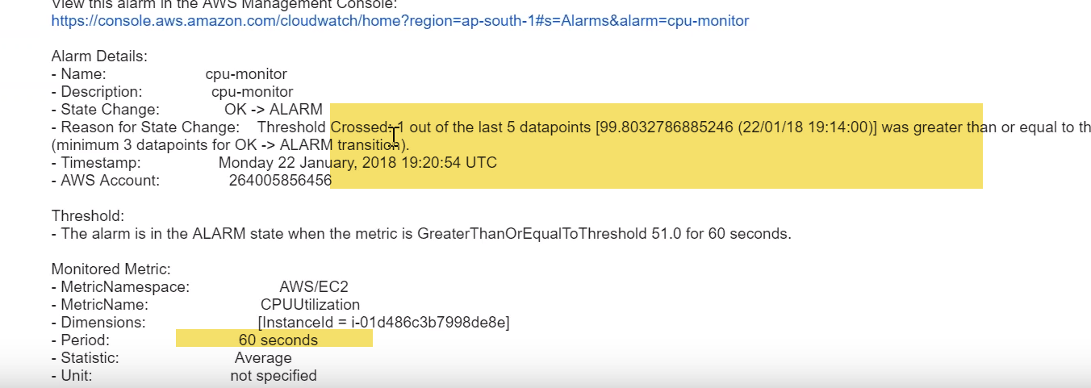

Period is for every 60 sec..